Lab 5: MicroBlaze Assembly Language Programming

Prerequisites
Prior to starting this guide make sure to perform Lab 3 and Lab 4 to understand how to use Vivado block diagrams to connect new IP to the MicroBlaze soft processor.

Part 1: Synthesizing Block Diagram in Vivado
1.) Create a new Xilinx Vivado project just as you did for Lab 1, Part 2: Getting Started in MicroBlaze. Call the Project “lab5p.xpr”. Then, create a new Block Diagram and name it “lab5q”. As a reminder, the steps are:
1.1: From the start page, select the Create New Project button to start the New Project Wizard.

1.2: Click Next to continue to the first step.

1.3: Set the name of the project to “lab5p”. Vivado will use this name when generating its folder structure.
Important: Do NOT use spaces in your project name or location path.
1.4 Choose Project Type as RTL Project. Leave the “Do not specify sources box” cleared and click Next.
1.5 Click next until you can select Boards. From the filter options make required selections for Vendor, Display Name and Board Revision. “Basys 3” should be displayed in the selection list. A mismatch in selecting the correct board name will cause errors. Choose Basys 3 and click next.
1.6 A summary of the new project design sources and target device is displayed. Click Finish.
1.7 On the left in the Flow Navigator, select Create Block Design under the IP Integrator, and name your design “lab5q”.

2.) In the Sources window, click the Board tab. Click and drag the following Basys3-related IP blocks into your empty block diagram:
2.1. Clocks System Clock. This places your sys_clock input port and also inserts a new Clocking Wizard. Double-click the Clocking Wizard block and select the Output Clocks tab to ensure that the Output Clock (clk_out1) is set to an Output Freq of 100 MHz and Active High Reset Type.
2.2 GPIO 16 Switches. This inserts a 1st AXI GPIO block, labeled “axi_gpio_0”, and connects its GPIO output port to a new external interface “dip_switches_16_bits”.
2.3 GPIO 4 Push Buttons. Drag this on top of the existing block named axi_gpio_0. It connects the GPIO2 output port to a new external interface “push_buttons_4bits”.
2.4 GPIO 7 segment display – Segments. This inserts a 2nd AXI GPIO block, labeled “axi_gpio_1”, and connects its GPIO output to a new external interface “seven_seg_led_disp”.
2.5 GPIO 7 segment display – Anodes. Drag this on top of the existing block named axi_gpio_1. It connects the GPIO2 output port to a new external interface “seven_seg_led_an”.
2.6 UART USB UART. This inserts a new AXI Uartlite block labeled “axi_uartlite_0”, and connects its UART output port to a new external interface “usb_uart”.
3.) In the Diagram window, select the Add IP icon, or right-click and select “Add IP…” from the context menu. In the search bar, enter the search term “microblaze”, which inserts MicroBlaze block.

4.) Next to where it displays “Designer Assistance available”, select Run Block Automation and a customization assistant window will open with default settings. Select the following Options:
Local Memory | 128 KB
Local Memory ECC / Cache Configuration | None
Debug Module | Debug Only
Peripheral AXI Port | Enabled
Interrupt Controller | Unchecked
Clock Connection | /clk_wiz_0/clk_out1 (100 MHz)
These settings automatically insert new MicroBlaze Debug Module (MDM), Processor System Reset, and microblaze_0_local_memory IP blocks.

5.) Next to where it displays “Designer Assistance available”, select Run Connection Automation, and a new window will open. Select the checkbox next to “All Automation”, and click OK. You should see that new connections have been drawn between the IP blocks.

6.) Select the Regenerate Layout () button to clean up the block diagram. The completed diagram should appear like the following:
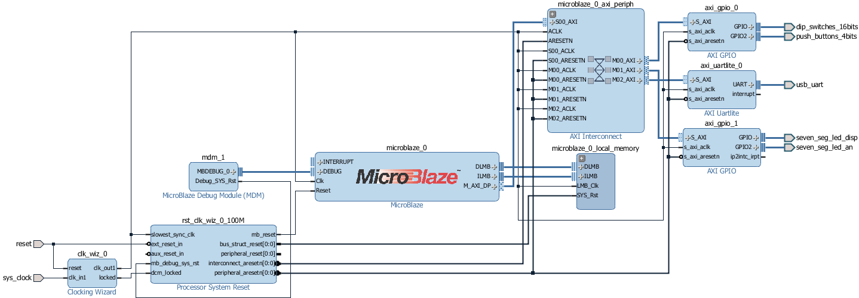
7.) Next, select the Validate Design () button to check for errors.
8.) Select the “Sources” tab. Below “Design Sources”, select your block diagram “lab5q” given by the icon, right-click it, and select “Create HDL Wrapper”. In the “Create HDL Wrapper” window that appears, select “Let Vivado manage wrapper and auto-update”, and then click OK.
9.) Before you try synthesizing your block design, select the “Address Editor” tab () next to the “Design” tab. Note down the “Offset Address” values for the axi_gpio_0, axi_gpio_1, and axi_uartlite_0 blocks here: axi_gpio_0: ____________________________________
axi_gpio_1: ________________________________ axi_uartlite_0: __________________________________
10.) In the Flow Navigator pane on the left side, select 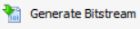 to generate a bitstream. Check the console to ensure that no errors have occurred during the Synthesis and Implementation phases.
11.) On the main toolbar, click File and select Export→Export Hardware. Check the box to Include Bitstream and click OK. This will export the hardware design with system wrapper for the Software Development Tool - Vivado SDK.
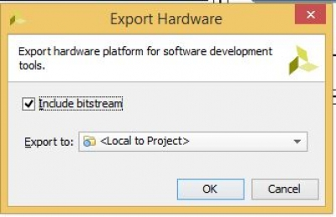
A new file directory will be created under lab5p.SDK similar to the Vivado hardware design project name. Two other files, .sysdef and .hdf are also created. This step essentially creates a new SDK Workspace.
In the Vivado top menu, click File and then Launch SDK. Leave both dropdown menus as their default Local to Project and click OK. This will open Xilinx SDK and import your hardware.
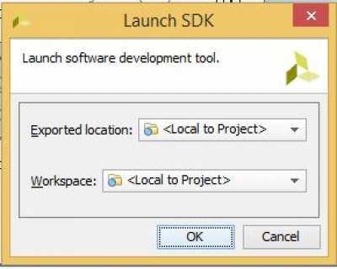

Part 2: Creating A Hello World Assembly Program in SDK
12.) In the SDK top menu, click the New dropdown arrow and select Xilinx→Application Project.
Give your project the name “lab5r” (with no empty spaces), ensure in the Hardware Platform dropdown box that the most recently exported Lab 5 HW platform is selected (lab5q_wrapper_hw_platform_0), and click Next. On the Templates page, select “Empty Application” and click Finish.

13.) In the Project Explorer, expand the “lab5r” project and the “src” folder. Right-click on the “src” folder, and from the Context menu, select New File. The New File window appears. Next to “File name”, enter “lab5s.s” or something similar ending with the .s extension.
14.) Double-click on lab5s.s to open the file in the SDK editor. On line 1, enter the following .set directive to equate a value (10) with a symbol name (NUMLOOPS):
#Equates
.set NUMLOOPS, 10

15.) On line 4, beneath the .set directive, declare the string “$msgBegin” using the following directives:
#Memory Section
$msgBegin:
.asciz "\r\n Program Start.\r\n"
.text
.align 2
16.) On line 10, beneath the Memory Section, add a main function to display the message by invoking the xil_printf function:
#Main Program
.globl main
main:
addi r5, r0, $msgBegin # Store string to print
addi r1, r1, -4 # Push r15 onto stack
swi r15,r1, 0
brlid r15,xil_printf # Call print func; retn addr in r15
nop # Unfilled delay slot
lwi r15,r1, 0 # Pop r15 off the stack
addi r1, r1, 4
17.) Save the S file. Program FPGA; on the top toolbar, click the Program FPGA button.
Start a TeraTerm (or similar) window using the same settings as in Labs 3 and 4. Build and run the executable. To do so, in the Project Explorer, right-click the “lab5r” project, and from the context menu select “Build Project.” Then, after the build has finished, right-click the “lab5r” project, and from the context menu, select Run As Launch on Hardware (System Debugger).
Ensure that you can see the “Program Start” terminal message.
18.) Copy the Memory Section (lines 5-8) directly below to lines 9-12 to declare a new String. Change the 2nd symbol name from “$msgBegin” to “$msgEnd”. Change the 2nd display string to include “Stop” instead of “Start”. Similarly, copy the main function to the bottom of the file, changing the label name from “main” to “done”, and changing the string to store into R5 from “$msgBegin” to “$msgEnd”.
19.) Save, build, and run the project again to ensure that you see both messages, “Program Start” and “Program Stop”. This time, you should just be able to select the Run As… button on the top toolbar, select Launch on Hardware (System Debugger), and click OK.
20.) Copy $msgBegin directly below again to declare a new String called “$msgLoop”, and assign it the message String: “Embedded Systems Loop #%2d.\r\n”. In the terminal, %2d will be a 2-digit loop integer value. Then, copy the main function directly below again, but before the done function. Rename the copied function label from “main” to “loop”, and change the String to print from “$msgBegin” to “$msgLoop”.
21.) In the main function, immediately before the start of the loop function, initialize general purpose registers R19 to NUMLOOPS and R20 to 1, using the addi instruction as shown:
addi r19, r0, NUMLOOPS # Initialize R19 to NUMLOOPS
addi r20, r0, 1 # Initialize R20 to one
22.) In the loop function, immediately after the “loop:” label, add a “branch if equal immediate” instruction that will jump to the line after the “done:” label if R19 equals zero. Then, insert a “no operation” (nop) instruction and decrement the loop counter in R19 by 1 using rsub as shown:
beqi r19, done # If R19==0, branch to done; stop program
nop
rsub r19,r20,r19 # Decrement loop counter (R19) by 1 (R20)

23.) Later in the loop function, on the line after R5 is set to $msgLoop, set the 2nd input argument, R6, to the current value of the loop counter in R19, using the addk (add and keep) instruction as shown:
addk r6, r19, r0 # Set R6 to loop counter value to print

24.) At the end of the loop function, just before the start of the “done” function, branch back to the loop label unconditionally using a “branch immediate” (bri) instruction, as shown:
bri loop
nop

25.) Save, build, and run the project again to ensure that you see all messages—“Program Start”, 10 loop iteration strings, and “Program Stop”.

Once you’ve completed these steps, you may continue, or call over instructor to mark you down for Pt 2.

Part 3: Getting Input and Putting Output Using UART and GPIO
In part 3, you will extend your existing “Hello World” program from Part 2 to take user input on the UART terminal or on GPIO switches, and also place output values on the 7-segment display. Please back up your working lab5s.s somewhere (i.e. save it into another folder away from the lab5p project) so that any changes you make for Part 3 won’t overwrite your work from Part 2.

26.) In the “Equates” section at the top of the program, add additional lines to set symbols to the memory addresses needed for reads and writes to UART and GPIO. Replace the question marks in the following code with the hexadecimal “Address Offset” values you wrote down in Step #9.
.set SWITCH_DATA, 0x????????
.set SEV_SEG_DATA, 0x????????
.set UART, 0x????????

27.) In the “Memory” section below the Equates section, add additional lines to declare a String for displaying the values of elements in an array, as follows:
$msgWithChar:
.asciz "Character %d - %c\r\n"
.text
.align 2

28.) Also in the Memory section, add additional lines to declare an array with label “$Nums”, which has 10 elements, each element 4 bytes in size, and initial values set to 65.
$Nums:
.fill 10, 4, 65
.data
.align 4

29.) In the main function, immediately before the start of the loop function, initialize general purpose registers R22 to 0 using the addi instruction as shown:
addi r22, r0, 0 # Initialize R22 to 0

R22 will be used as a pointer to the addresses in the array $Nums.

30.) In the loop function, identify the lines where you branch if R19==0, and decrement R19 by 1. Change the destination of the branch from “done” to “disp”:
beqi r19, disp # If R19==0, branch to done; stop program
To clean up the code, you may delete all lines between the rsub instruction line and the “bri loop” line. After the rsub instruction, load the bit values from the GPIO Switch, and store those same bit values into the GPIO 7-segment display, as shown:
lwi r11, r0, SWITCH_DATA # Read data from switches
swi r11, r0, SEV_SEG_DATA # Write switch data to 7-segment disp

31.) Immediately after these new lines, add more lines to read a character (Byte) from UART. You must first load the 1st input argument register R5 with the UART memory address before calling XUartLite_RecvByte:
addi r5, r0, UART # Set R5 arg to UART memory address
addi r1, r1, -4 # Push r15 onto stack
swi r15, r1, 0
brlid r15, XUartLite_RecvByte # Call UART Receive function
nop
lwi r15, r1, 0 # Pop r15 off stack
addi r1, r1, 4
After returning from the XUartLite_RecvByte function, the received character is in the 1st output argument register, R3.

32.) Immediately afterward, add more lines to print out the character (Byte) at the UART.
swi r3, r22, $Nums # Store value into $Nums array at offset R22
Immediately afterward, add more lines to print out the character (Byte) at the UART. The 1st input argument (UART memory address) is already loaded into R5. You must first load the 2nd input argument register R6 with the character to print out before calling the XUartLite_SendByte function.
add r6, r0, r3 # Move char R3 into R6 to display to UART
addi r1, r1, -4 # Push r15 on stack
swi r15, r1, 0
brlid r15, XUartLite_SendByte # Call Uart Send function
nop
lwi r15, r1, 0 # Pop r15 off stack
addi r1, r1, 4
Immediately afterward, add another line to increment our array iterator R22 by 4 (since our array elements were defined to be 4 bytes apart):
addi r22, r22, 4 # Increment R22 by 4 bytes
The line following this code should be the “bri loop” instruction.

33.) Before the done function, add a new disp function using the same syntax that you used to create all prior functions. On the 1st line, reinitialize the loop iterator R19 to 10 and the array iterator R22 to 0 in the same way that you did in the main function:
.globl disp
disp:
addi r19, r0, NUMLOOPS # Reinitialize R19 to NUMLOOPS
addi r22, r0, 0 # Reinitialize R22 to zero

34.) Next, create a loop construct to iterate through each memory address in your $Nums array, and display the value to the UART terminal using the xil_printf function:
.globl loop2
loop2:
beqi r19, done # If R19==0, branch to done; stop program
nop
rsub r19,r20,r19 # Decrement loop counter (R19) by 1 (R20)
addi r5, r0, $msgWithChar # 1st arg R5 is format string
add r6, r0, r22 # 2nd arg R6 is address offset
lwi r7, r22, $Nums # 3rd arg R7 is array value at this offset
addi r1, r1, -4 # Push r15 on stack
swi r15, r1, 0
brlid r15, xil_printf # Call printf
nop
lwi r15, r1, 0 # Pop r15 off stack
addi r1, r1, 4
addi r22, r22, 4 # Increment R22 by 4 bytes
bri loop2
The line following this code should be the “.globl done” directive.

35.) Save, build, and run the project. At terminal, enter 10 characters. Between each entry, toggle switches to ensure that you see the proper 7-segment displays lit.
Once you’ve completed these steps, you may continue, or call over instructor to mark you down for Pt 3.

Part 4: Sorting a List of User Provided Integers

For Part 4, you will implement functionality to sort the user-entered characters before display.
While you’re encouraged to implement this logic on your own, you are welcome to note the following hints:
- The simplest method of sorting integers is the Bubble sort, which compares adjacent array elements and swaps each pair if their values are in the wrong order, as shown in the following C-style pseudocode:
for (10 iterations) {
for (i=0; i<9; i++) {
if (a[i]>a[i+1]) { /* Then, swap a[i] and a[i+1] */
tmp=a[i]; a[i]=a[i+1]; a[i+1]=tmp;
}
}
- You may set up another function using the label “sort” to handle the sorting algorithm between the loop function and the disp function. The sort function may incorporate two nested labels (e.g. for1 and for2) to manage the nested for loops.
- You should use the remaining general purpose registers to act as an additional loop iterator for the outer for loop and address offset for a[i+1]. Consider using R23 and R24 for these purposes.
Note that the Bubble sort algorithm mentioned above is not ideal, since its run time is always O(N²). Consider other sorting algorithms you may have learned about to perform the sorting. What potential issues could you anticipate from implementing a recursive algorithm like merge sort in assembly language?

Once you’ve completed these steps, you may call over the instructor to mark you down for Part 4.

